Route(id, departure_airport, arrival_airport, rprice) id -> (departure_airport, arrival_airport, rprice)

City(id, name, country) id -> (name, country)



Airport(code, name, city) code -> (name, city)

WeeklyFlight(id, time, day_of_week, wschedule, route) id -> (“everything else”)

WeeklySchedule(year, profit_factor) year -> profit_factor

Flight(fnumber, week, nbookings, wflight) fnumber -> (week, nbookings, wflight)

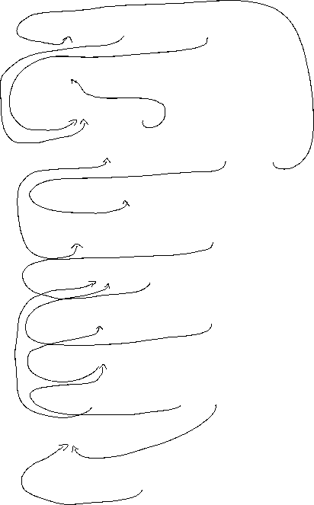

Reservation(rnumber, flight) rnumber -> flight

Passenger(passport, name, ticket, reservation) passport -> name

(passport, reservation) -> (name, ticket)

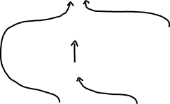

This one isn’t in BCNF form, but we didn’t want

to create two relations, because most of the time people don’t have a lot of reservations at the same time, so we didn’t consider the redundancy to be a problem

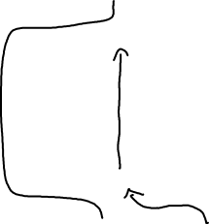

Contact(passengerid, email, phone) passengerid -> (email, phone)

Booking(reservation, price, contact, payer) reservation -> (price, contact, payer)



Payer(id, name) id -> name



CreditCard(number, owner) number -> owner